**Swedish Massage**

Swedish massage was pioneered by a Swedish physiologist, Henri Peter Ling, at the University of Stockholm in 1812. It was introduced to the U.S. in 1858 as "The Swedish Movement Cure." **Swedish massage is the foundation for other types of Western massage**, including sports massage, deep tissue massage and aromatherapy massage.

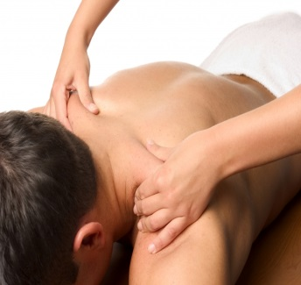During Swedish massage, massage therapists use massage oils to facilitate smooth, gliding strokes called effleurage. Other classic Swedish massage moves include kneading, friction, stretching and (sometimes) tapping. Active or passive movements of the joints may also be part of the massage. **The benefits of Swedish massage include increased blood circulation, mental and physical relaxation, decreased stress and muscle tension, and improved range of motion.** Swedish massage uses firm but gentle pressure to promote relaxation, ease muscle tension and create other health benefits.

Generally during Swedish massage you're nude underneath a towel or sheet. The massage therapist uncovers only the part of the body he/she is working on, a technique called draping. You can keep your underwear on during Swedish massage, and many newcomers do.

**Feel free to state your preference for pressure during Swedish massage.** It can range from light to firm. Swedish massage usually includes some deeper work on areas of specific muscle tension. If you want more intensive work and firmer pressure, ask for a deep tissue massage.

Chair Massage  
Swedish Massage  
Shiatsu Massage  
Thai Massage

**Home** 